**CCNA 1 Chapter 2 V4.0 Answers 100% updated 2011**

**1**. **Which statements correctly identify the role of intermediary devices in the network? (Choose three.)**  
determine pathways for data  
initiate data communications  
retime and retransmit data signals  
originate the flow of data  
manage data flows  
final termination point for data flow

**2**. **Select the statements that are correct concerning network protocols. (Choose three.)**  
define the structure of layer specific PDU’s   
dictate how to accomplish layer functions  
outline the functions necessary for communications between layers   
limit the need for hardware compatibility  
require layer dependent encapsulations   
eliminate standardization among vendors

**3**. **What are two functions of encapsulation? (Choose two.)**  
tracks delay between end devices  
enables consistent network paths for communication  
allows modification of the original data before transmission  
identifies pieces of data as part of the same communication   
ensures that data pieces can be directed to the correct receiving end device

**4**. **What is a primary function of the trailer information added by the data link layer encapsulation?**  
supports error detection   
ensures ordered arrival of data  
provides delivery to correct destination  
identifies the devices on the local network  
assists intermediary devices with processing and path selection

**5**. **Which two layers of the OSI model have the same functions as the TCP/IP model Network Access Layer? (Choose two.)**  
Network  
Transport  
Physical   
Data Link  
Session

**6**. **What is a PDU?**  
corruption of a frame during transmission  
data reassembled at the destination  
retransmitted packets due to lost communication  
a layer specific encapsulation

**7**. **Which characteristic correctly refers to end devices in a network?**  
manage data flows  
originate data flow   
retime and retransmit data signals  
determine pathways for data

**8**.

[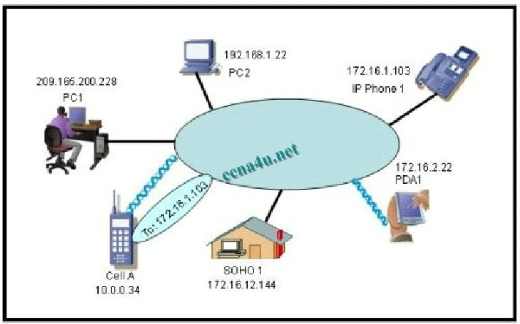](http://www.ccna4u.org/?attachment_id=131)

ccna 1 chapter 2

**Refer to the exhibit. “Cell A” at IP address 10.0.0.34 has established an IP session with “IP Phone 1″ at IP address 172.16.1.103. Based upon the graphic, which device type best describes the function of wireless device “Cell A?”**  
the destination device  
an end device  
an intermediate device  
a media device

**9**.

[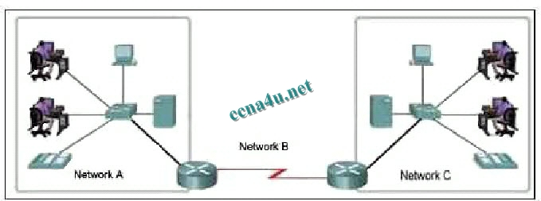](http://answers.ccna4u.net/wp-content/uploads/2011/01/9.jpg)

ccna 1 chapter 2

**Refer to the exhibit. Which three labels correctly identify the network types for the network segments that are shown? (Choose three.)**  
Network A — WAN  
Network B — WAN  
Network C — LAN  
Network B — MAN  
Network C — WAN  
Network A – LAN

**10**. **Which three statements best describe a Local Area Network (LAN)? (Choose three.)**  
A LAN is usually in a single geographical area.  
The network is administered by a single organization.  
The connection between segments in the LAN is usually through a leased connection.  
The security and access control of the network are controlled by a service provider.  
A LAN provides network services and access to applications for users within a common organization.  
Each end of the network is generally connected to a Telecommunication Service Provider (TSP).

**11**.

[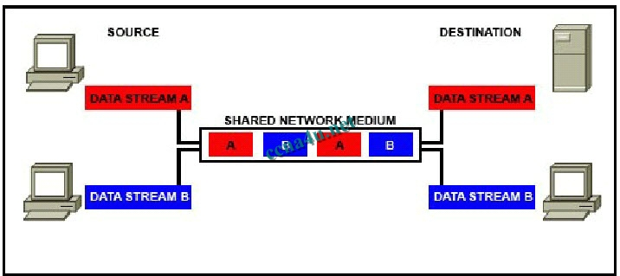](http://answers.ccna4u.net/wp-content/uploads/2011/01/11.jpg)

ccna 1 chapter 2

**Refer to the exhibit. Which networking term describes the data interleaving process represented in the graphic?**  
piping  
PDU  
streaming  
multiplexing  
encapsulation

**12**. **What is the primary purpose of Layer 4 port assignment?**  
to identify devices on the local media  
to identify the hops between source and destination  
to identify to the intermediary devices the best path through the network  
to identify the source and destination end devices that are communicating  
to identify the processes or services that are communicating within the end devices

**13**. **What device is considered an intermediary device?**  
file server  
IP phone  
laptop  
printer  
switch

**14**.

[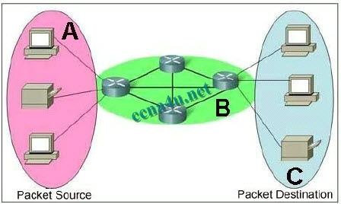](http://answers.ccna4u.net/wp-content/uploads/2011/01/14.jpg)

ccna 1 chapter 2

**Refer to the exhibit. Which term correctly identifies the device type that is included in the area B?**  
source  
end  
transfer  
intermediary

**15**.

[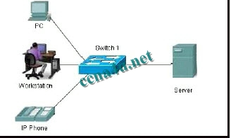](http://answers.ccna4u.net/wp-content/uploads/2011/01/15.jpg)

ccna 1 chapter 2

**Refer to the exhibit. What type of network is shown?**  
WAN  
MAN  
LAN  
WLAN

**16**. **Which layer encapsulates the segment into packets?**  
physical  
data link  
network  
transport

**17**. **What can be identified by examining the network layer header?**  
the destination device on the local media  
the destination host address  
the bits that will be transferred over the media  
the source application or process creating the data

**18**.

[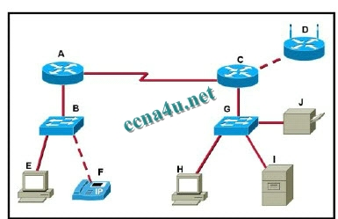](http://www.ccna4u.org/?attachment_id=136)

ccna 1 chapter 2

**Refer to the exhibit. Which set of devices contains only end devices?**  
A, C, D  
B, E, G, H  
C, D, G, H, I, J  
D, E, F, H, I, J  
E, F, H, I, J

**19**. **During the encapsulation process, what occurs at the data link layer?**  
No address is added.  
The logical address is added.  
The physical address is added.  
The process port number is added.

**20**. **What is the purpose of the TCP/IP Network Access layer?**  
path determination and packet switching  
data presentation  
reliability, flow control, and error detection  
network media control  
the division of segments into packets

**21**. **What is the proper order of the layers of the OSI model from the highest layer to the lowest layer?**  
physical, network, application, data link, presentation, session, transport  
application, physical, session, transport, network, data link, presentation  
application, presentation, physical, session, data link, transport, network  
application, presentation, session, transport, network, data link, physical  
presentation, data link, session, transport, network, physical, application